DATE: 06.09.2019
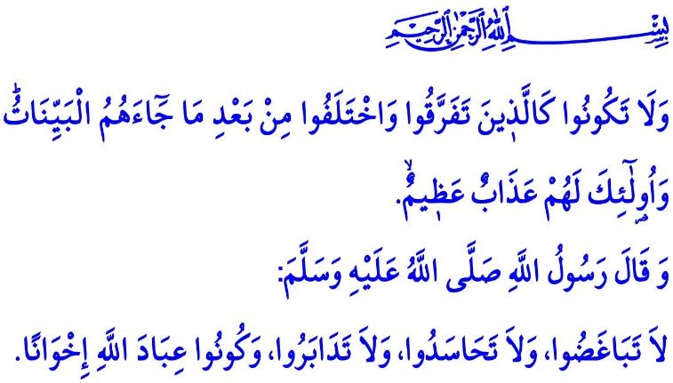
THE MONTH OF MUHARRAM AND
THE DAY OF ASHURA
Honorable Muslims!
As the Almighty Allah (swt) states in the Holy Qur'an, “The number of months in the sight of Allah is twelve.” One of these months that we are currently in is the month of Muharram. It is an exceptional period of time blessed by the mercy of Allah.The Prophet Muhammad (saw) referred to the abundance of spiritual blessings in this month by saying, “The most excellent fast after Ramadan is the fast in Allah's month al-Muharram.”
Dear Believers!
The month of Muharram holds a special place in our history and our culture as well. The month of Muharram is the month of Ashura. Ashura is one of the symbols of our unity, togetherness, sharing, and solidarity. Just as the ashura as a food brings together a variety of ingredients and creates a balanced flavor, our nation, as required by the ethics of living together, has for centuries been sharing the joy and sorrow, the blessings and hardships, and the affection and hard feelings.
Dear Muslims!
The month of Muharram is also the month in which the Battle of Karbala took place, which is our shared sorrow and the heart wound of our history. Over 70 Muslims, the majority of whom were from Ahl al-Bayt, including the Prophet Muhammad's (saw) grandson Hussein, were martyred in Karbala. Karbala is the name of a challenging test and a deep sorrow. Karbala is a heavy experience bequeathed by the Prophet Muhammad's (saw) family members for centuries to come. Muslims whose hearts burn and heave a painful sigh today at the mention of Karbala and Hussein should contemplate about Karbala, understand it correctly, and draw lessons from it.
Dear Believers!
In order to understand Karbala, one needs to be knowledgeable about Hussein. Hussein was an honorable believer following the path of his grandfather Muhammad Mustafa (saw), the Last of the Prophets (Khatam al-Nabiyyin). He was a graceful Muslim who stood against injustice and oppression, and set his heart on upholding the truth, justice, loyalty, fidelity, and righteousness. To love him requires defending the values he sacrificed his life for. For he is a sublime example of an honorable life and a noble stance for all generations and centuries to come. It is a duty upon us to embrace his faith and morals, and, at the same time, to pass down his personality traits of bravery and self-sacrifice to our young people.
Dear Muslims!
The greatest message of the month of Muharram for us Muslims is to hold on to our unity and peace, and to never make any concessions on our brotherhood. The Almighty Allah (swt) warns us in the Holy Qur'an, “Be not like those who are divided amongst themselves and fall into disputations after receiving Clear Signs. For them is a dreadful penalty.” Similarly, the Prophet Muhammad (saw) says, “Do not hate one another. Do not be jealous of one another, and do not desert each other. O the worshippers of Allah! Be brothers.”
Dear Muslims!
Let us unite our hearts of the same faith, the same pain, and the same longing, in order not to let new incidents of Karbala take place. Let us spare rooms in our hearts for each other, and embellish our lives with affection. Let us deal with our shared sorrows and problems in need of solution through discernment, prudence, sense of responsibility, and sensitivity. Let us lock together around the sacred values that make us “us”. Let us make Hussein's nobility and good morals our distinctive marks.
I would like to take this opportunity to commemorate, wishing Allah's mercy upon and with heartfelt gratitude for, Hussein the leader of martyrs, in particular, and all our martyrs who sacrificed their lives for the truth, freedom and independence, dignity and sacred values, from Karbala to today.
As I conclude the khutbah, I would like to point out another point. As you know, the new school year is just around the corner. The next Monday, schools will open insha'allah. I would like to take this opportunity to pray Allah the Almighty (swt) that the new school year may lead to good developments for our children who are our hope for the future, for all students at any academic level, and for our dear teachers and parents of our students. May Allah (swt) allow our children to have a healthy, peaceful, and successful school year, and enable them to equip themselves with knowledge, skills, and experience that they can use for the benefit of our country, nation, and for all humanity.

Tawbah, 9/36.
Muslim, Siyam, 202.
Al-i 'Imran, 3/105.
Bukhari, Adab, 57 General Directorate of Religious Services

